**COVER LETTER**

**Sourav Ganguly**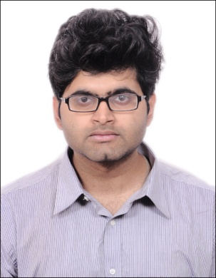  
SRI NILAYAM PG(GENTS), #19, 3 rd Cross, Green Garden Layout, Sai Nagar Road  
Kundalahalli Gate, Bangalore-560037  
**Contact No.:**  +91-8334895299 / +919051477873  
**Email:**  [souravganguly707@gmail.com](mailto:souravganguly707@gmail.com)  
**Alternate Email:** [souravganguly707@yahoo.com](mailto:souravganguly707@yahoo.com)  
**Date:** 28/11/2017

Dear Sir,

 I would like to apply for **SYSTEM ANALYST** within your company **SIEMENS.**

I believe this position would provide me a great opportunity for further my chosen career.  I am Sourav Ganguly, passed out my B.Tech in IT from Calcutta Institute Of Engineering and management in the year of 2016. My willingness to work hard and build my skill base will make me a good candidate for the job.

My 7 month of career work has introduced me to  [vb.net](http://vb.net/" \t "_blank), sql server, mysql server, ms access, java, c#, Visual Studio 2012, ASP.NET, SQL Server, Troubleshooting.

The key strengths that I possess for success in this position include:

* I have successfully designed, developed, and supported live use Windows Applications
* I strive for continued excellence
* I provide exceptional contributions to customer service for all customers

With a B.TECH degree in INFORMATION TECHNOLOGY, I have a full understanding of the full lifecycle of a software development project. I also have experience in learning and excelling at new technologies as needed.

 I have attached my resume along with my job post. Please have a look. I can be reached anytime via email at [souravganguly707@gmail.com](mailto:souravganguly707@gmail.com) [/ souravganguly707@yahoo.com](mailto:/%20souravganguly707@yahoo.com) or my cell phone, +91-8334895299

Thank you for your time and consideration. I look forward to speaking with you about this employment opportunity.  
  
Sincerely,  
Sourav Ganguly